Summer camp 2018 details for the poster: flyer to follow from this

* Both are for infants (Reception – Yr 2) and juniors (Yr 3 – Yr 6)
* Time : 9am to 3 pm
* Boys and Girls (children from all schools invited)
* Required to bring snack, drink and packed lunch (nut free)
* Prices (All material included):

**Week 1 : 29th July (Monday) to 2nd August (Friday) at Moss hall infants**

**Week 2 : 5th August (Monday) to 9th August (Friday) at Moss Hall Infants**

Week 3 : 12th **August (Monday) to 16th August (Friday) at Woodridge Primary school**

**Full price: Week 1/2/3 (5 Days): £45 per day / £200 per week**

**Early Booking price: Week 1/2/3 (5 days): £40 per day**

**Any 1 Full Week : £180**

**Any 2 Full Weeks : 340 (saves you £60)**

**All 3 Full Weeks : £500 (saves you £100)**

*Please book by* ***Friday 5th of July 2019*** *to avail of the early booking discount*

*Need to check other camps what early booking dates they have*

* Please contact **Archita Goenka on 07967544402 or archita@addoarts.co.uk**

*Spaces limited; offered on a first-come first-serve basis*

* Woodridge Primary school – week 3

Venue : Woodridge Primary School, Southover, North Finchley, London N12 7HE

* Moss hall infants – week 1 and 2

Venue: Venue: Moss Hall Infants School, 38 Moss Hall Grove, London N12 8PB

* This will be again art and craft, cooking, dance, fun and games. Need some fun pictures general to start then once I decide specific pics

Digital crafting different levels for infants and juniors

Photo albums making different levels for infants and juniors

Delicious summer recipes

Bouncy castle?? Still to figure out the prices

* Also start thinking about the main flyer also. Maybe get 2-3 options ready. Both for online and printing.
* Also need to upload on facebook and whatapps versions
* Poster also on facebook and whatsapp and emails

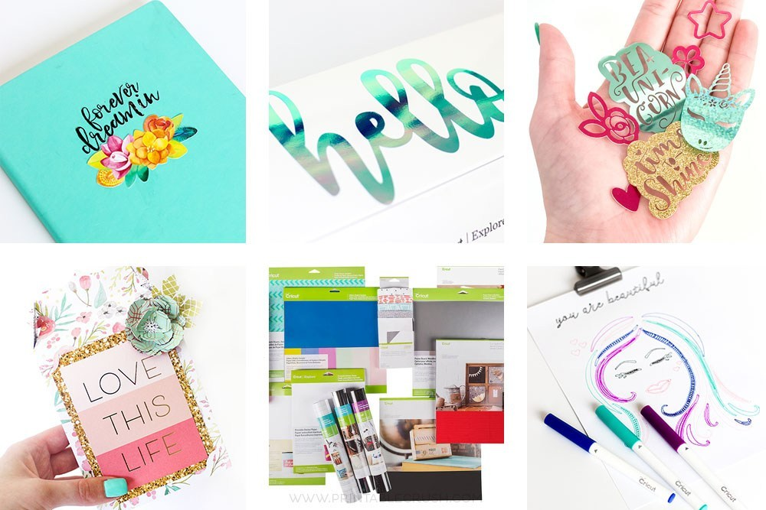

Digital crafting ideas

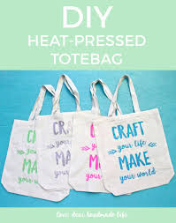 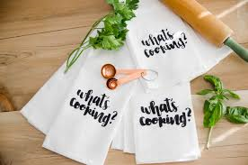 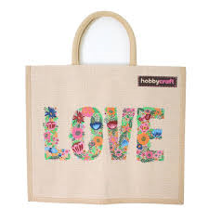 

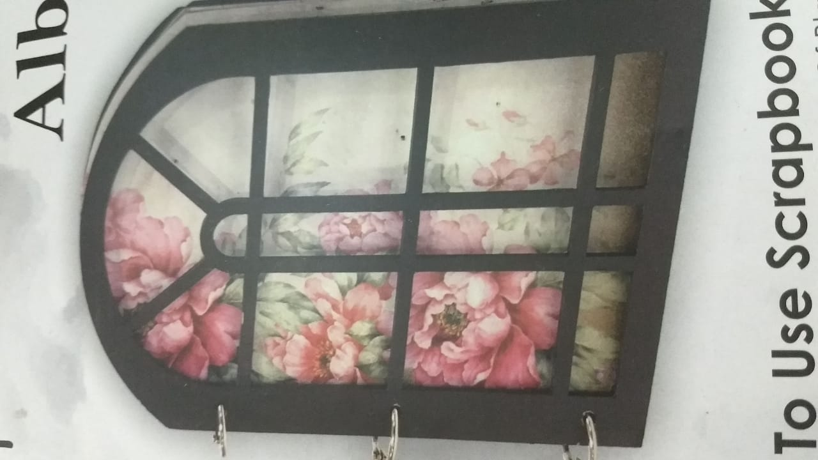 

Photo album completely designed and personalised by children wrong scratch

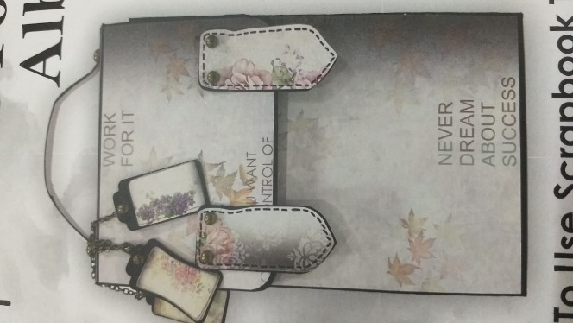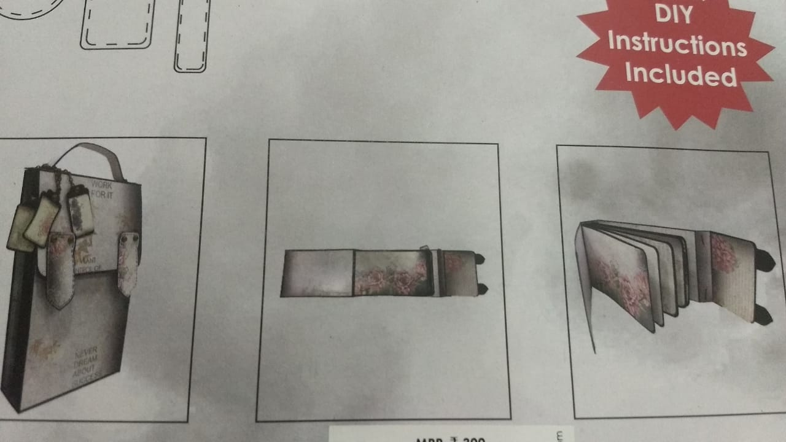

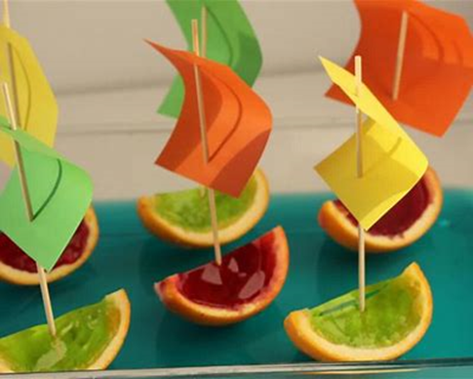

Jelly boats recipe

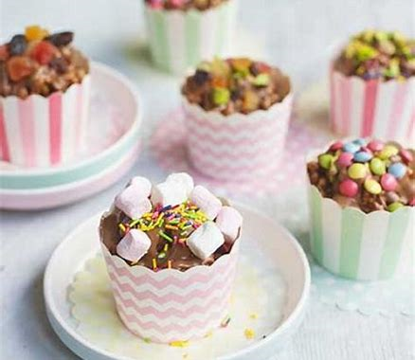 Rice crispy and hidden treats chocolate mini cakes

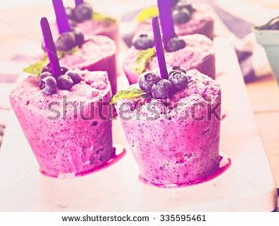

Blueberry popsicles

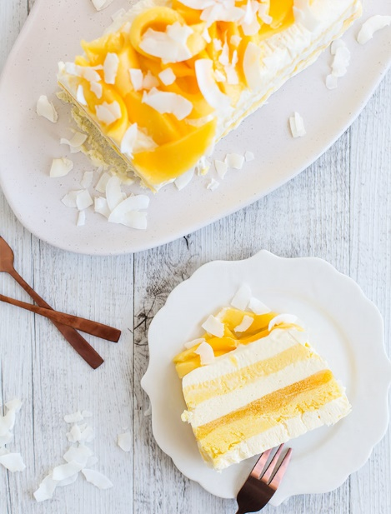 Mango ice cream cake

Corn and cheese kababs

